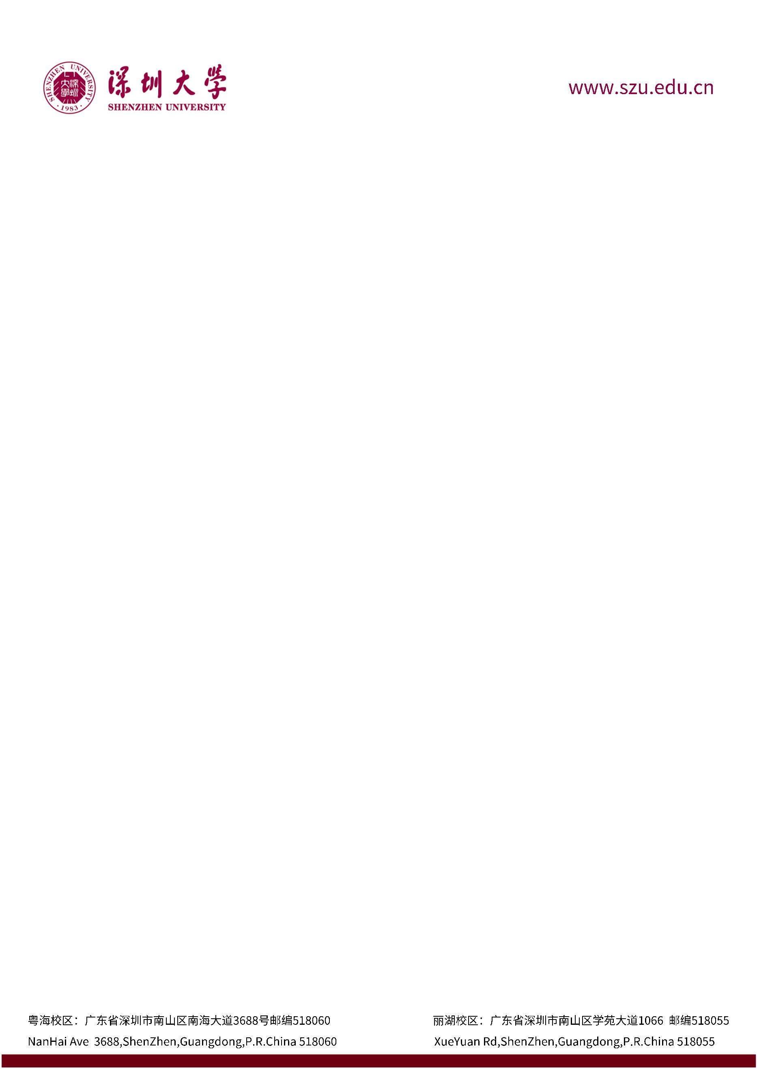

**June 22, 2023**

0755-2653-1309

Dear Admissions Committee members,

I am writing this letter to strongly recommend Liangming Huang for admission to The University of Manchester. As a professor at Shenzhen University, I have had the pleasure of teaching Liangming Huang in several courses and have been impressed by their academic prowess, diligence, and enthusiasm for learning.

I first met Huang in OOP during the second semester of the first academic year, where he immediately stood out as a top performer. The course demands a high level of analytical and problem-solving skills. Liangming Huang consistently demonstrated these abilities, achieving a final grade of A.

Liangming Huang possesses an extraordinary insight, which not only enables him to quickly grasp the fundamental knowledge of the curriculum but also inspires a continuous stream of innovative thinking. When faced with new knowledge, he always approaches learning and exploration with a positive and insightful attitude. He is not only adept at mastering knowledge but also skillfully applies what he has learned to practice. Among the students in the courses I teach, he has always been one of the top performers. He sought my advice on internships and competitions, which allowed me to see that he is equally motivated and hands-on outside the classroom, achieving notable success in various fields. I am very satisfied with Huang's abilities and mindset, and I believe he will continue to shine brightly on his future path.

I am therefore confident that Liangming Huang will prove himself to be a valuable student for Manchester University and a capable student for the Manchester Computing Department.

If you need any additional information or have any questions, please do not hesitate to contac me.

Sincerely,

Jiancong Bai. Ph D

Lecturer

Shenzhen University